Self Service – with News, Chat, Surveys – Quick Flow Demo Card

SMA-X 2017.11

# Background

|  |  |
| --- | --- |
| Key Messages | * Intelligent self-services, social, engaging UX – encourages employees to actually use ESS & to find own solution or guides them *to* solution; along with automation, this reduces load on IT * Allows IT to mine knowledge, improve service levels (without increasing load) * Superior KM powered by Micro Focus’ Big Data platform, yet as easy and as engaging as Facebook or Twitter * Unlimited # end users (others charge beyond certain #, and charge for approvers) |
| Customer Challenge | * IT can’t keep up with demand – service suffers * Users going outside IT (Google, friends) – lose visibility to need and how to improve, business looks for alternatives. * Need a new system of engagement that enables IT to mine knowledge, create business insights. |
| Engage Them | * Looking to reduce L1 ticket traffic? * ESS tool today? Used consistently? * How is your organization learning from experience? Are you managing knowledge? * The same data is used along the complete value chain of processes – from Self Service, to Service Support, Catalog Fulfillment, and Incident Resolution |
| Differentiators | * End user support is presented through an automated bot that will guide the user down a preferred path. * The bot uses a Big Data search to provide suggestions from a variety of sources, both structured (KM and other SMA-X records) as well as unstructured (Q&A). * Pre-configured Service and Support offerings improve productivity by standardizing request fulfillment and improve customer satisfaction by expediting resolution with auto-assignment and categorization. * Make better use of survey responses by using Big Data analytics to understand patterns in the textual answers in a survey. * SMA-X taps on-line translation tools to provide in-line translation of support requests and their updates between self-service users and agents. This feature enables effective support between users and their service desk in a global multi-national type deployment. |

# Quick Flow

The goal of the Quick Flow demo card is to provide a benefit oriented *overview*, to *introduce* the customer to value and solution. It should be completed in ~5-10 minutes; optional sub-flows to demonstrate more of the solution may be included below. Make sure your demo environment is ready – see demo set up below. After practicing and perfecting the flow, you might want to copy and paste the rightmost Cheat Sheet column (below) to serve as a printed or electronic guide during the demo.

**Use Case #1: Offering guided support to business user**

1. Self-service user looks for solution from Virtual Agent
2. Self-service user initiates a pre-defined support request
3. Self-service user chats with live agent
4. Live Agent resolves issue
5. Self-Service user accepts solution
6. Self-Service user takes survey

**Use Case #2: Easy ticket creation from screenshot**

1. Self-service user submits Smart Ticket with screenshot
2. Agent sees scanned image and ticket is automatically categorized and service is populated

**Use Case #3: View Service Subscriptions and Assets**

1. Self-service user views their assets and service subscriptions and related information
2. Self-service user submits support request and her laptop device is automatically populated

| **Do** | **Say** | **Cheat Sheet** |
| --- | --- | --- |
| **Use Case #1: Offering guided support to business user**  *Scenario – A business user is having a problem that needs to be resolved.*   * Login as [amy.lopez](mailto:amy.lopezhpe@gmail.com)mf in Chrome * In ESS Home Page, click on **Virtual Agent** button within the top bar * Type **“Email on mobile”** as a description and press Post * Various results are suggested – including Articles, Q&A, and Offerings.   + Select an Article – **“(DEMO) How to receive emails on my mobile device”,** Read it and click **“This does not help me”** * Select the **“(Demo) Report mobile phone email connection problem”** link * Check the **“Using webmail”** checkbox (so no manual task will be required), optional to fill in the device info, and **submit** the request. * Click on **“Chat”** * You should see a message indicating you are now waiting for a Support Agent | * End user support is presented through an automated bot that will guide the user down a preferred path. * The bot uses a Big Data search to provide suggestions from a variety of sources, including:   + Articles   + News   + Q&A   + Public Requests   + Catalog offerings * Support offerings are presented so that the user will select one of them and thus enter a more context specific path where the additional user option questions and automatic assignment rules can be leveraged * Note that the options in the drop-down boxes for subsequent options will vary depending on prior selections in the options above. | * Virtual Agent * Problem Desc: Email on mobile * KM Article: (DEMO) How to receive emails … * Support offering: (Demo) Report mobile phone with Webmail checked * Yes to Chat request |
| **Agent-to-ESS Chat**   * Login as [Jennifer.falconmf](mailto:Jennifer.falconhpe@gmail.com) in Internet Explorer as an Agent user. * Navigate to **Service Request**, and select the **My Chat Requests** inbox view * **Expand right side panel** to view details of the requests. * Click on **“Live Chat”** button and start chatting with the ESS user still logged in within the other browser | * End user chat is typically enabled only for certain Support Offerings – you have control to decide what topics will be supported by Live agents. This is controlled by the Service Level Agreement definitions associated with the Services in your Catalog. | * SRM, My Chat view * Live Chat button |
| **Resolve the request:**   * *If you have been showing the Chat feature already, the user’s request is already open by the Agent. Otherwise, search for the Request from within an inbox*. * Resolve the request: type in a **Solution** and a **completion code**, and **save** the request * At this point, the request should move to Accept mode | * Note how the OOB best practice support flow allows end users to confirm or deny if their problem was resolved properly. | * Tasks, Validate, Save * Solution and Completion code |
| **End User Accepts and Takes Survey**   * Back in **ESS** as Amy - Top Right “TODO” Avatar should have indicator count in red (may need to refresh the browser) * Click on the **TODO Avatar** to display the User’s tasks, and note that it includes one for accepting the request that was just solved. Click on **Accept**. *(Note that the user also gets an email to do the same, and you can show this email notification in gmail as Amy if you like)* * At this point, the request should be automatically closed, and a Survey generated * Again, in your **TODO Avatar**, you will have a pending task to complete the survey. Click Take Survey. (You can also look in Amy’s gmail inbox for the Survey notification, and proceed to answer by clicking on a rating in the email.) This will open the **Survey** in full in a Tab, where you can complete the remaining questions. | * The ESS user is always kept up to date with the status of their requests. * Email notifications let them know of any new updates by the Service Desk. * In addition, the ESS portal provides an intuitive notification alert that lets users know when there are interesting updates or actions pending their attention – this could include actions such as accepting a solution, taking a survey, or approving a request. | * ESS * ToDo * Accept * ToDo * Take Survey |
| **Review Survey Results**   * As Jennifer, navigate to the Survey Application and open the “IT Support Satisfaction Survey” * Show the Reports and Hot Topic tabs to highlight how easy it is to see results. | * SMA-X uses Big Data analytics to provide special value when reviewing Survey Results. * Hot Topics provide a great way to understand patterns in the textual answers in a survey. * The reporting charts can include valuable data from the Survey sliced and filtered by cross-referenced data from the related request records (or any record associated with the Survey). This you can see Survey results grouped by Help Desk Group, Support Category, Support Location, etc. | * Agent * Survey * IT Support Satisfaction Survey * Reports tab * Hot Topics tab |
| **Use Case #2: Easy ticket creation from screenshot** |  |  |
| * In Chrome – as amy.lopezmf, Click “New Request” in the ribbon bar. | * Amy is facing an issue that her laptop can’t be shut down normally. She takes a picture to the blue screen and decides to submit a support request. | * ESS * New Request |
| * Type “email on mobile won’t connect” in the description field. * Drag a screenshot file into the description field, click Submit |  | * Drag/drop screenshot |
| * The request is generated, click on the request number and then click the View Full Details arrow to review the request details. Scroll down to see the scan results below the image. | * The OCR (Optical Character Recognition) works in backend so that the text in the blue screen picture is automatically extracted and appended to the request description. |  |
| * In IE, as Jennifer.falconmf, go to Service Request application, Select the “All” view, and find the newly created request | * The agent finds that Category and Service have been set automatically. With the help of machine learning engine, the self-service request has been classified automatically so that agent is able to process the request more efficiently. | * Agent * Service Request |
| **Use Case #3: View Service Subscriptions and Assets**  **[See Setup section for key details]**   * As Amy Lopez, (an ESS user) * Click on “Services and Assets” within the Menu drop down on the top right of the screen * Select your Laptop subscription * Now highlight the 360 degree information on your subscribed service   + Show overview section with laptop configuration details   + Expand the History section to show past requests   + Related articles show more information relevant for PCs   + Feedback from users let you know how others have experienced the same service * Now back at the top expand the “Support” section to show related offerings that can be requested   + Select Repair my PC hardware, notice that Amy’s PC has been populated into the Device field. Fill in description and submit the request | * With “Services and Assets” users can see a personalized catalog of the specific Services, Applications, and Hardware that have been provided to them. * Each item provides a “360” view around the provided service, and this includes:   + Configuration details   + Related offerings   + History of requests   + Related article knowledge and news   + Social comments * As support or related offerings are requested, specific links to the user’s service, application, or asset are included in in the request ticket, enabling faster more accurate support or automation | * ESS * Services and Assets * Laptop * Request support |

# Optional Sub Flows

Customer intrigued after seeing this overview? Want to show more of the solution? Ideas for possible sub-flows/drill-downs:

| **Do** | **Say** |
| --- | --- |
| **In-line Translation Demo**  [Be sure to follow the pre-setup instructions outlined below]   1. As a Self Service User, navigate to Request Support and open a new Support Ticket – add a description complaining that the Coffee machine is not working. You can add it in French, for example:   “La machine à café ne fonctionne pas. Le café sort trop liquide et pas assez forte .”  (Note – it does not matter what Language preference you have in your profile. Just type or copy any text you want. You can go to <https://translate.google.com/> to pre-create some source text in various language.)   1. Now as an Agent, open the same ticket, and view its Detail page. Within the Description field, press the Translate button to view it in the Agent’s language. (Here the translation will convert the source text to the Agent’s language according to Profile settings) 2. As an agent, add some comments. You can add a few comments in various languages, stating to “Try changing the filter and adding new ground coffee”. Here are some samples in various languages:   Essayez de changer le filtre et l'ajout de nouveaux marc de café  Versuchen Sie, die Filter und das Hinzufügen neuer Kaffeesatz.  尝试改变过滤器和增加新的咖啡渣。   1. Now go back to ESS, view the status of the ticket. Hover over the comments and press Translate to view in the ESS user’s language. | * SMA-X taps on-line translation tools to provide in-line translation of support requests and their updates between self-service users and agents. * This feature enables effective support between users and their service desk in a global multi-national type deployment. * Note that the functionality shown here is powered by Google translate. The actual quality and accuracy of the translation is dependent on that engine. Customers need to license a Google Translate key separately. |

More detailed flows will be required for POC type efforts (not provided).

# Demo Preparation

Demo data prep includes initial set-up tasks and items that must be checked before each demo (e.g., demo data changes over time, or to return to the pre-demo state). Be mindful of whether the changes are appropriate or needed for the demo tenant you’re using – e.g., for the shared demos, initial set-up is probably already done, and some changes shouldn’t be applied (e.g., theme)

## Self-Service Portal Button settings

In the agent UI as a tenant admin, go to Administration > Self-Service Portal Settings > Feature Settings and configure the portal Ribbon promotion to: Virtual Agent, New Request, Ask Friends, Suggest Idea, and Save.

Collect screenshot images

Place screenshot images for OCR scan use case on desktop of system where you will submit your Smart Request.

## Survey Set-up

* IT Satisfaction Survey
* Add a Business Rule to the Request Process so that a Survey is sent automatically when the request is closed, as shown below in the Entering rule section for the Close Phase of the Support Process flow:

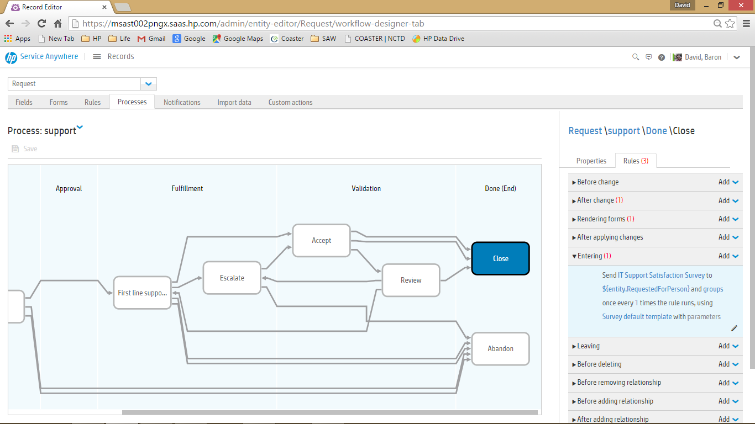

Send

IT Support Satisfaction Survey

 to

${entity.RequestedByPerson}

 and

groups

 once every

1

 times the rule runs, using

Survey default template

 with

parameters

* You can also pre-seed your user’s portal with Surveys by using the “Send Survey Now” button within the definition of the “IT Support Satisfaction Survey”

## Setup for Subscription Demo

* As an agent go to SACM and select Subscriptions from the SACM Home menu, and create one or more subscriptions assigned to your Portal user, Amy Lopez – you can look at the existing OOB examples and copy these
* Be sure to create a subscription for Amy Lopez to one laptop device, such as HPPC001, under the “PC Lifecycle” service definition
* Add skill to Amy Lopez’s profile for Elitebook so she will see user questions on this topic.
* Add organizational group, IT, with email [IT.group@advantage.com](mailto:IT.group@advantage.com) and configure Kimberly and Jennifer to be in this group.
* Configure Amy and Joe as members of the Marketing organizational group and add an email address for this group to [Marketing.group@advantage.com](mailto:Marketing.group@advantage.com)
* Create a view for subscriptions for “Active subscriptions” that has a filter for Active is true and adds the Subscriber Group field right after the Subscriber column.

## Setup for In-line Translation Demo

* Note: A translation key has not been installed in the shared demo environment on AWS. You would need to obtain a translation API service for Google Translate. You can see detail for obtaining a license key in the attached guide. For details on getting such a key, see the section on Google Translation below.
* Input your Google translation key:
* Go to Administration/Application Settings
* Turn on in-line translation, and enter the Google Translate key you obtained in Step 1
* To perform the demo most effectively, you could log-on in two browsers using different users, each one having a different default Language in their profile. But for efficiency the demo above will use a single user. You can create tickets and type descriptions (as ESS) or comments (as an Agent) in any language. During translation, the text will be converted to your user’s preferred language according to their profile.

## Obtain a Google Translation Key

